MUEngage for Service Learners
Marquette’s new community engagement tracking system for community service, service learning, and more!

MUEngage is the new community engagement tracking system for Marquette University. Within the Service Learning Program, MUEngage replaces the in-person sign-up night. Students can now sign-up for service learning online, record their impacts (i.e. service learning hours, projects, and presentations), and register for reflection sessions. This instructional guide was designed for service learners. Do not hesitate to contact the Service Learning Program- servicelearning@marquette.edu with questions or concerns.

How to Create a MUEngage Account

All students must create a MUEngage account to sign-up for service learning.

- Go to engage.mu.edu

- Click LOG IN in the upper right hand corner

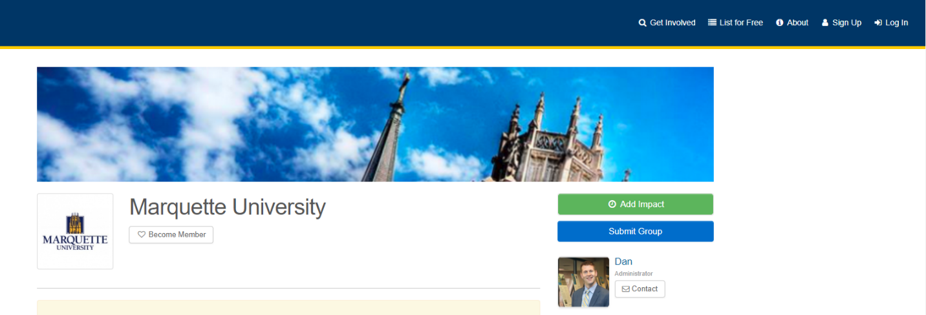

- Click LOG IN VIA CHECKMARQ

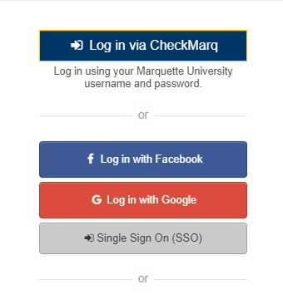

- You will be directed to this screen → enter your MU Credentials

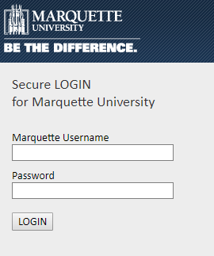

- Follow steps to fill out PROFILE → SET UP NEW ACCOUNT

Find Your Service Learning Course Group On MUEngage

Once you set up your profile, you are now a “member” of your service learning course group on MUEngage. “Members” (that’s you…the student) will register for service learning opportunities through their service learning class group on MUEngage.
Your Dashboard is a space to browse events and opportunities in progress:
- Search, register and attend events and opportunities
- Track service hours (i.e. impacts) for service learning

There are 2 ways to find your Service Learning Course On MUEngage…

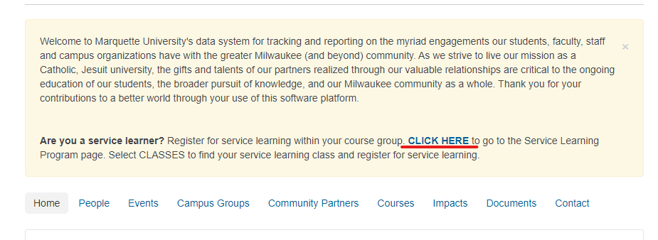
Option 1) Select ‘CLICK HERE’ on the Marquette University Landing Page where it says “Are you a service learner?”

Select the ‘Classes’ Tab and appropriate semester. Then search and select the correct course AND section number you are doing Service Learning for.
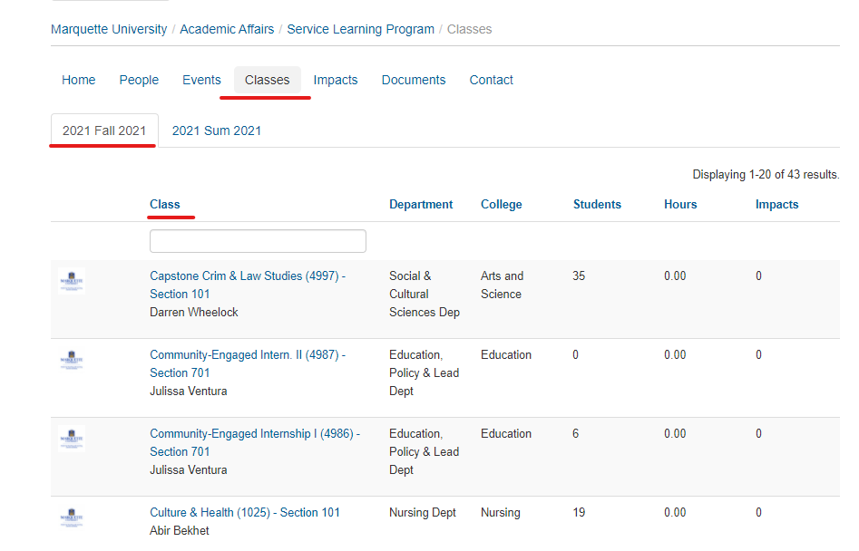

Once you select the correct course you can proceed to view the preapproved ‘Events’ by your professor. See page 7 for more details on browsing ‘Events’
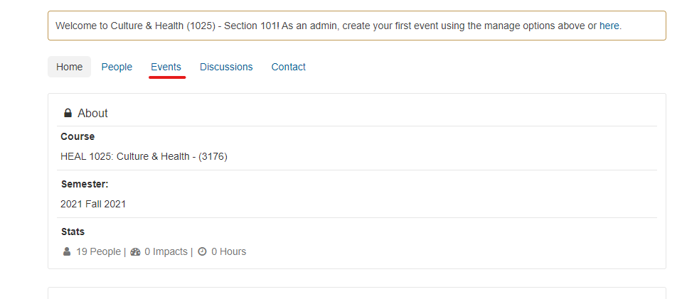

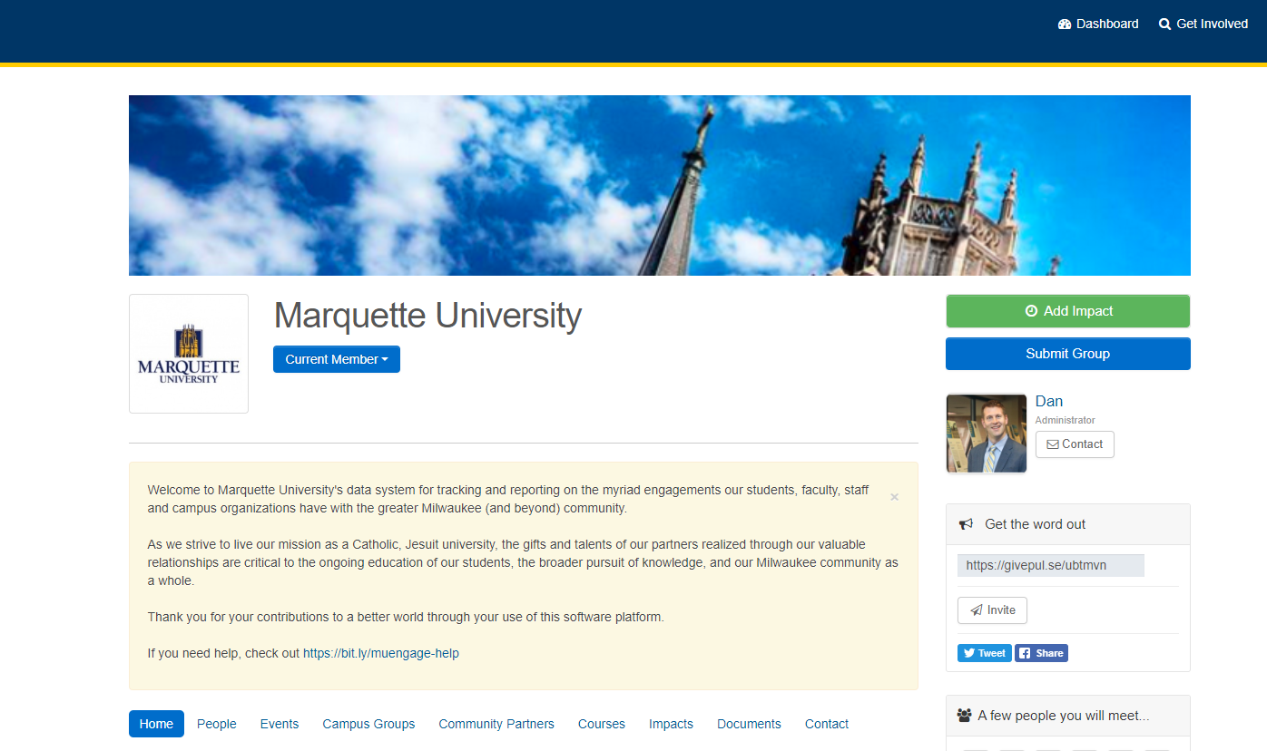
Option 2) In the top bar, click your name and select DASHBOARD. In the dashboard, in the MEMBERSHIPS section, click the CLASSES TAB to see the list of your service learning courses.

On this dashboard, you can view your MEMBERSHIP to your service learning course.
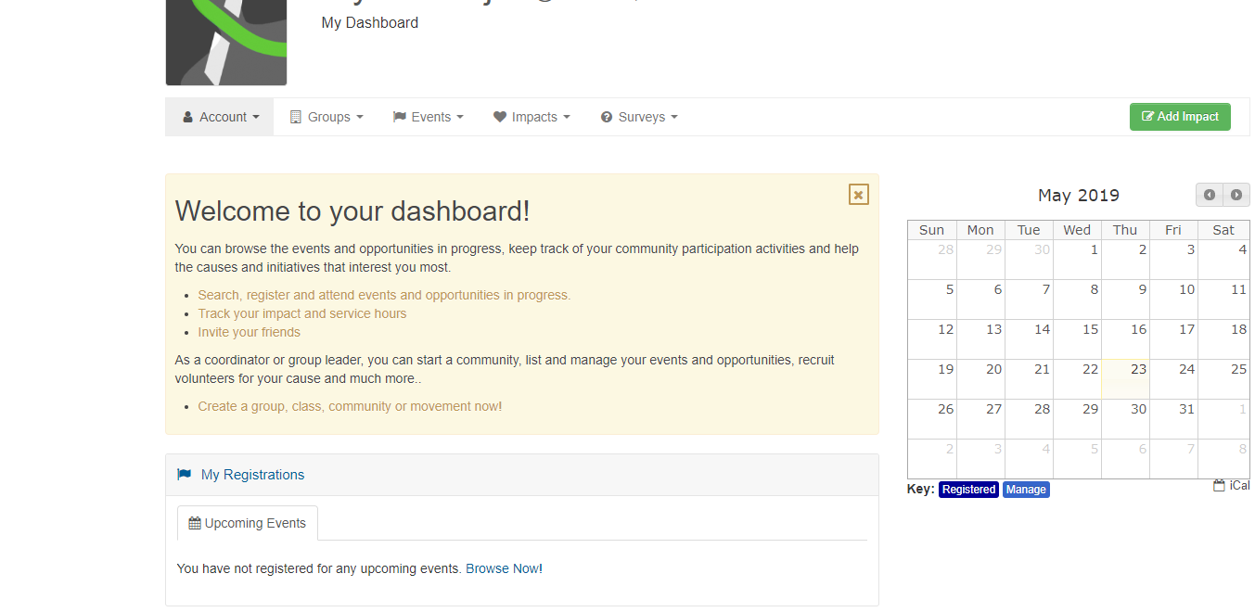

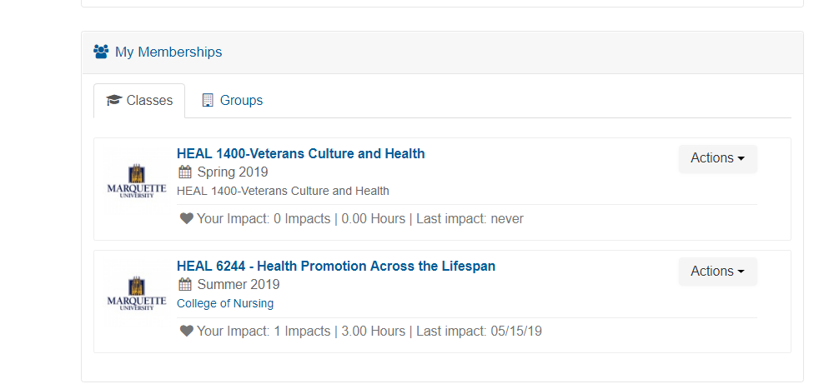

CLICK on your SERVICE LEARNING COURSE to view upcoming service learning opportunities before registration (i.e. sign-up) day.
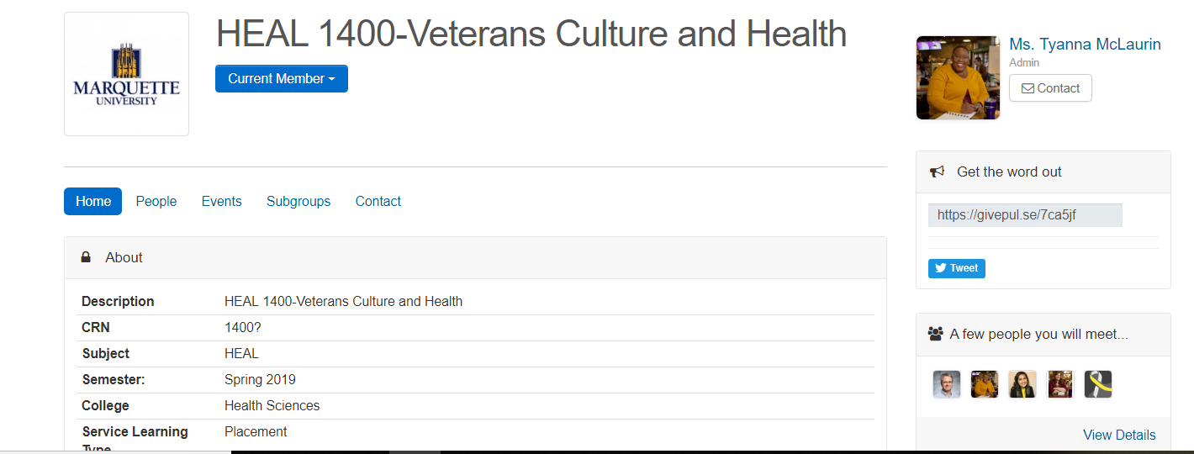

You cannot register for site placements before the official registration (sign-up) day. Information on Sign-Up Day is included on the Service Learning Program’s Checklist of Important Dates (found on the service learning website). You can also access information on registration day on the service learning program website.

How to Register for a Service Learning Opportunity

All students will register (i.e. sign-up) for service learning on MUEngage. Before registration day, students can preview service learning opportunities within service learning course group. Once you register, your Student Coordinator will follow up with you with additional trainings and/or requirements you need to complete to start your service.

There are two types of service learning opportunities: RECURRING and OPEN OPPORTUNITY. Recurring events are opportunities where this is a set day and time of service every week. Open Opportunity is where the organization will allow you to pick your day and time of service each week.

Recurring Events/Service Learning Opportunities

Find the Service Learning course that you are a member of under your MU Engage Profile.

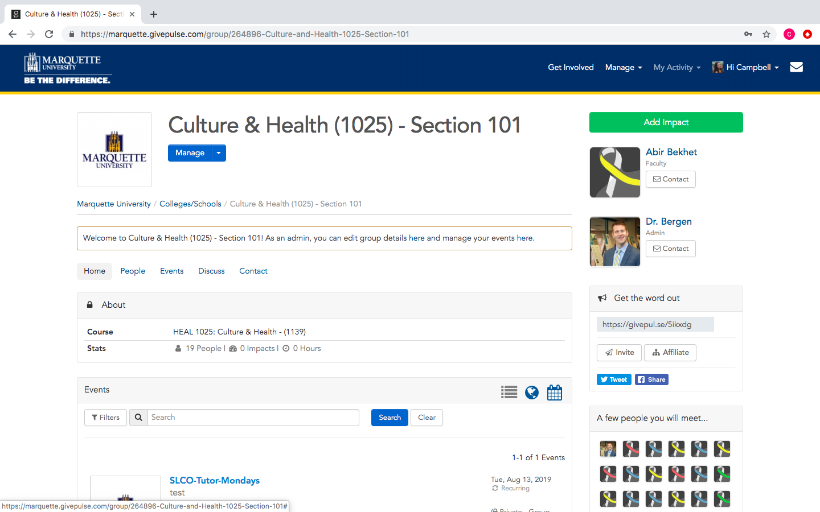

Once you find your service learning course. CLICK on the EVENTS TAB or scroll through the webpage to see the various options for site placements for your course.

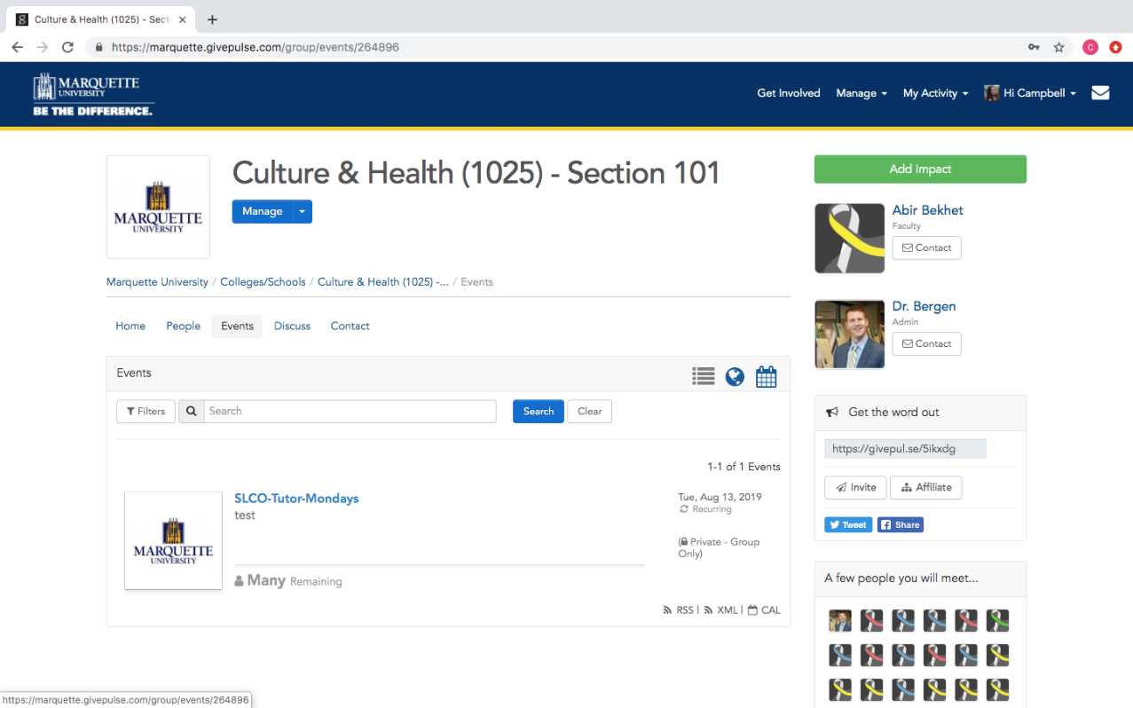

Or you can select the calendar view to see different times and dates that are available for registration.
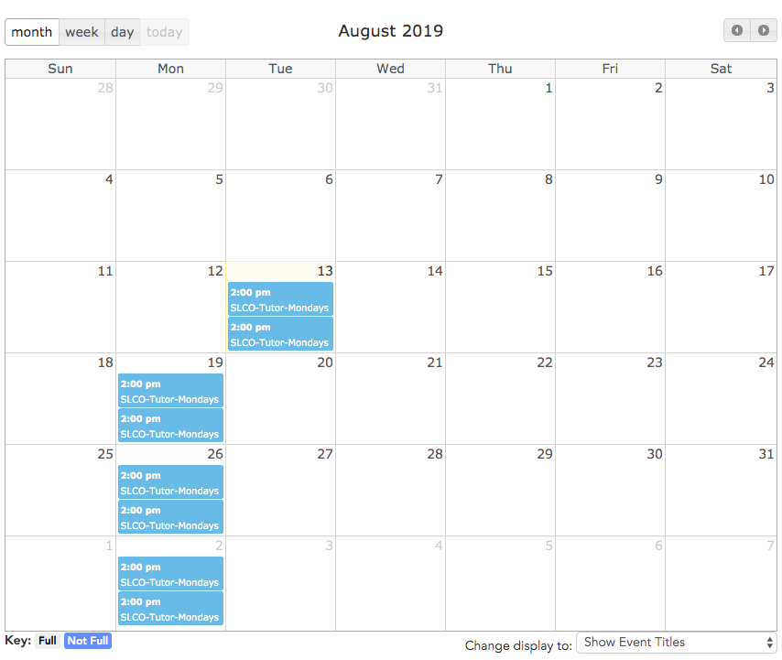

Once you choose a weekly volunteer opportunity that you find the most fitting, CLICK REGISTER.

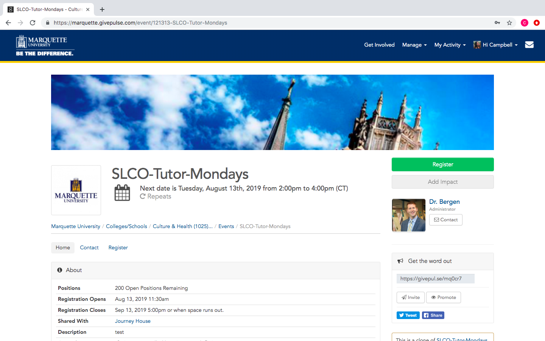

You will click through multiple tabs to register for a site placement.

In the SELECT DATES TAB, make sure that you check the box for every week in the semester.

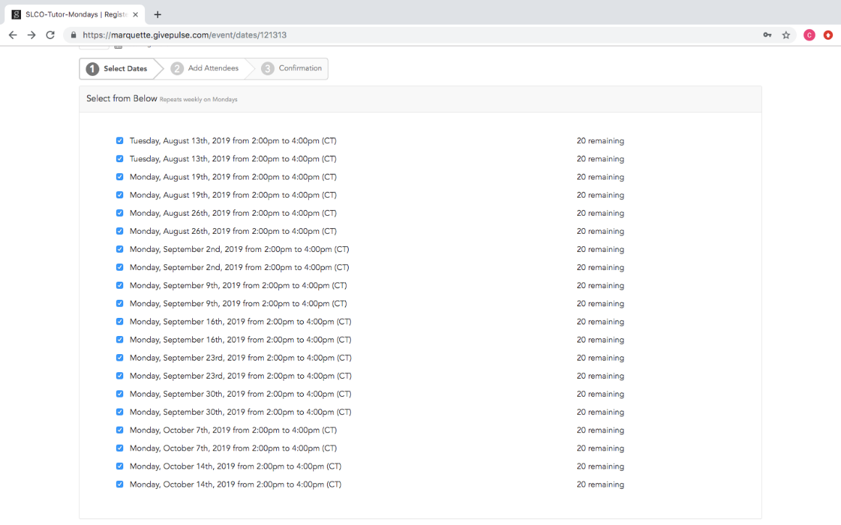

In the ADD ATTENDEES TAB, you will see your name. You must CHECK THE BOXES TO AGREE to liability waivers and release forms.
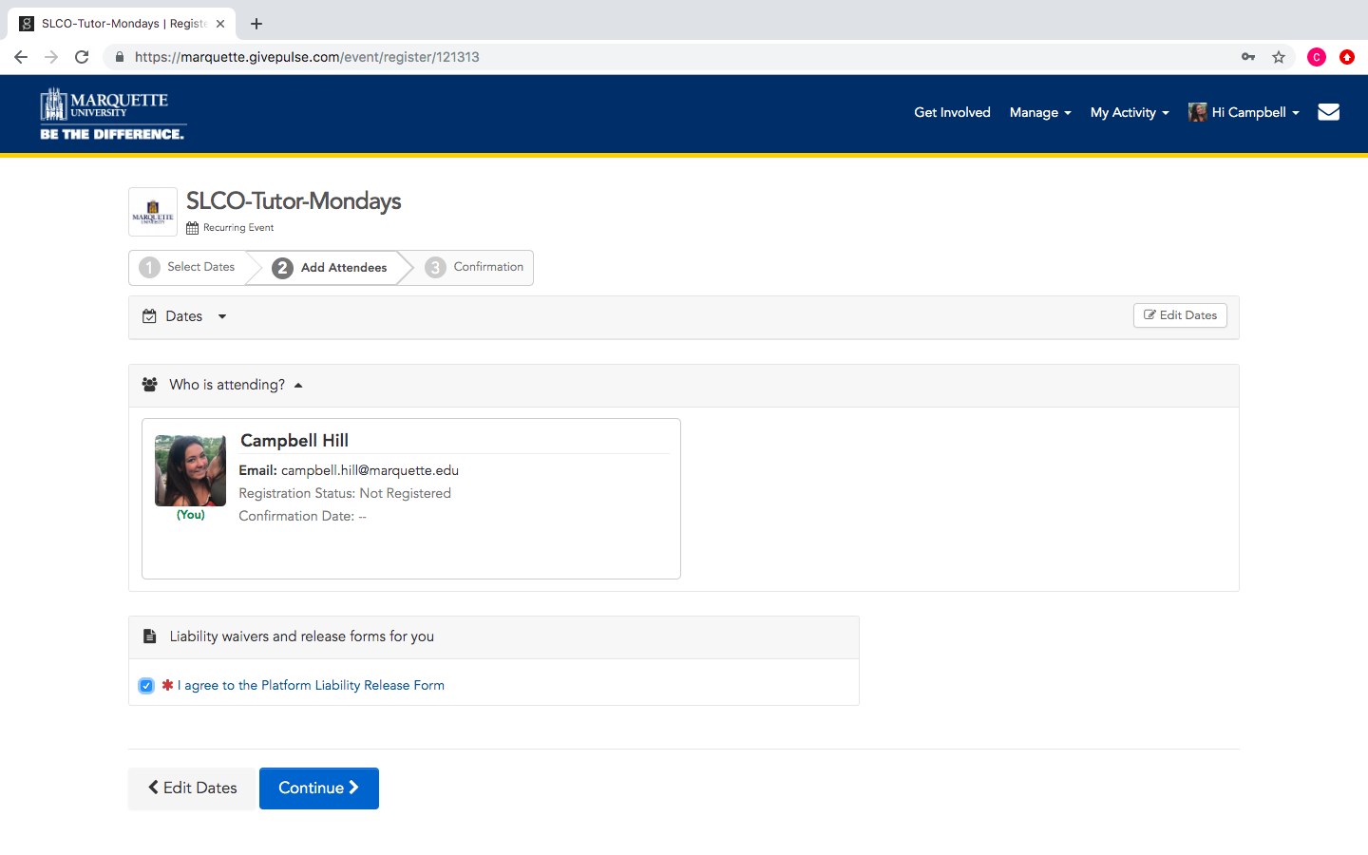

You should see a CONFIRMATION PAGE. Make sure that everything looks right, and you should be good to go!

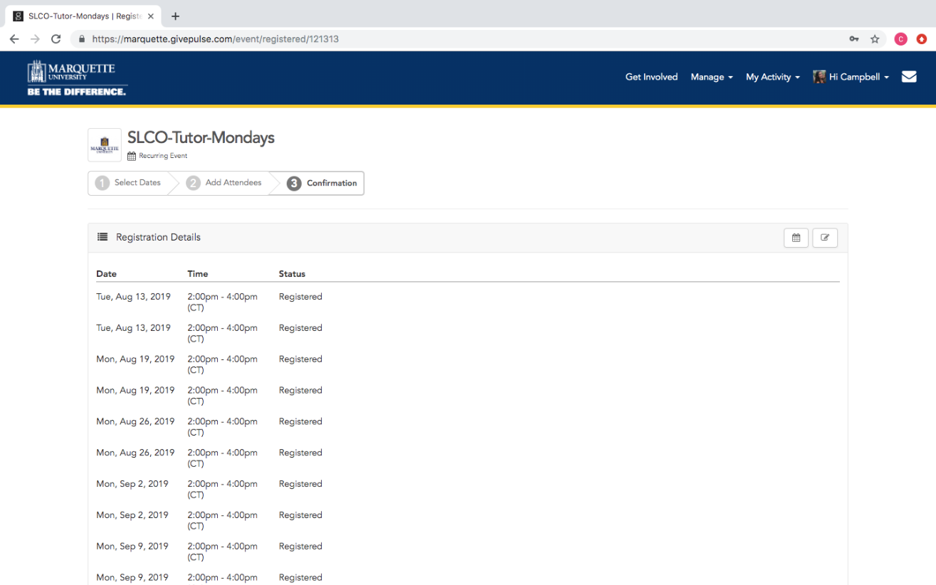

You will also receive two confirmation emails; an automatic email from MUEngage and an email from a Student Coordinator with information on additional steps you need to complete for the organization before you start your service.

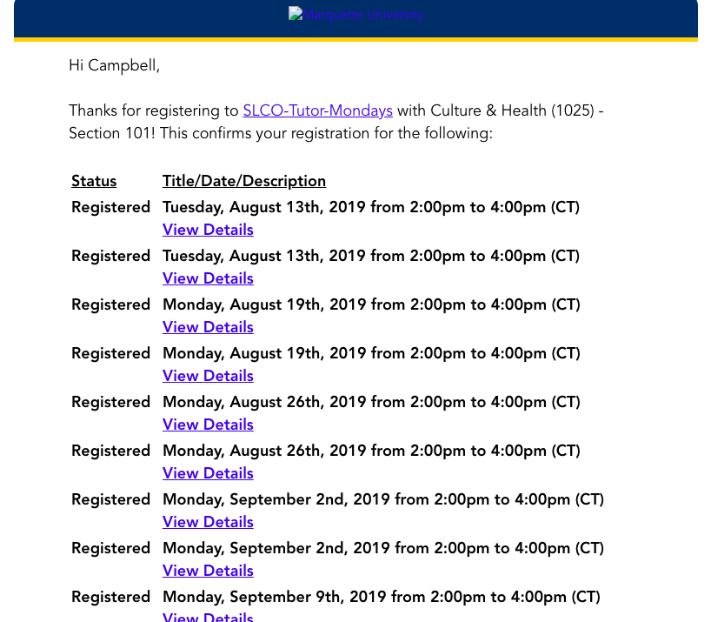

Open Opportunity Events/Service Learning Opportunities

Find the Service Learning course that you are a member of under your MU Engage Profile.
Once you find your service learning course. CLICK on the EVENTS TAB or to scroll through the webpage to see the various options for site placements for your course.
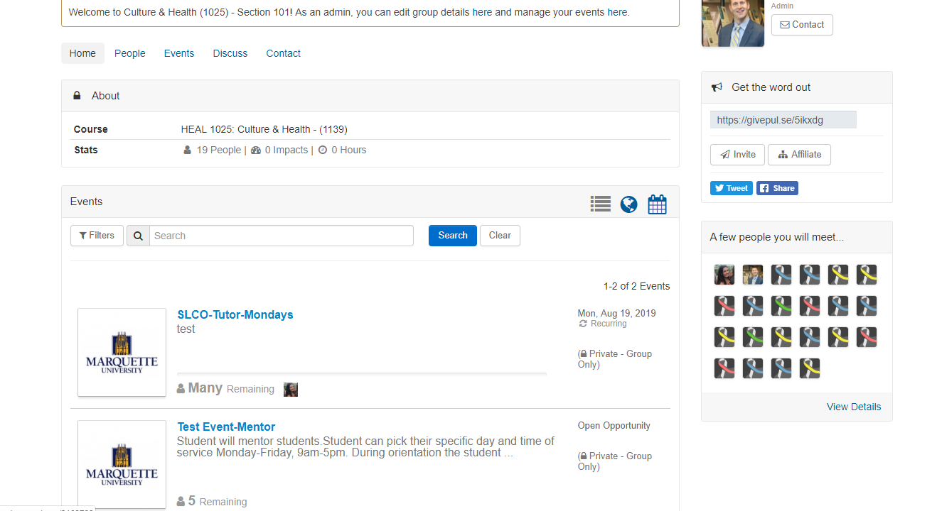

If the event/service learning opportunity is an OPEN OPPORTUNITY, it will say under the event title. This means that you can choose your day and/or time of service each week
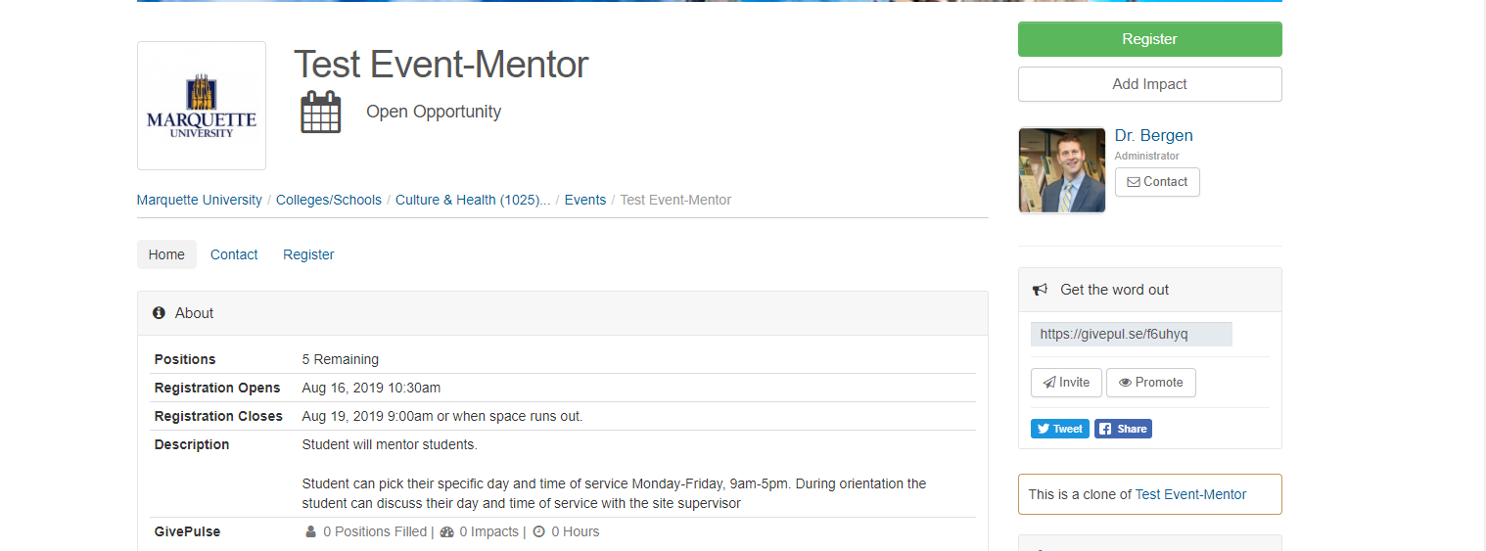
Click REGISTER

Make sure you check the boxes for the LIABILITY WAIVERS AND RELEASE and click CONTINUE

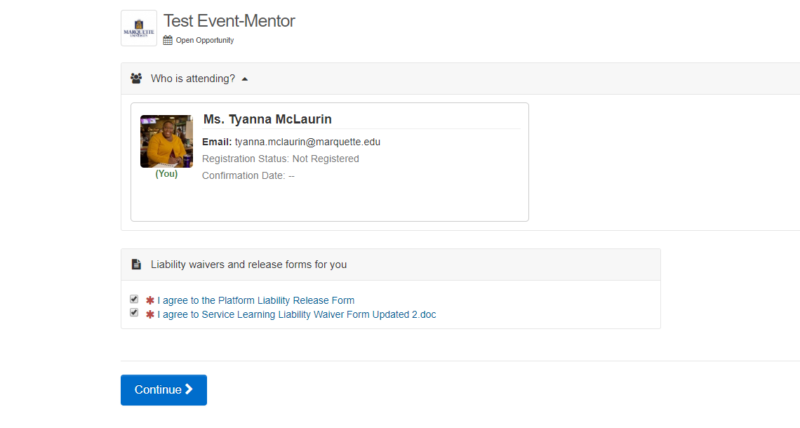

You should see a CONFIRMATION PAGE
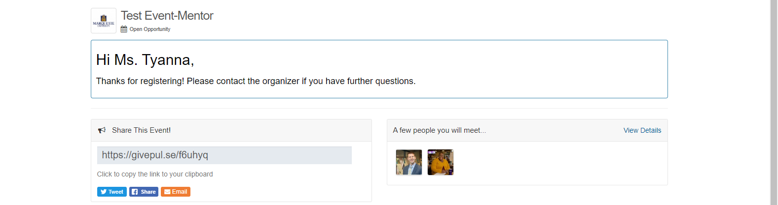

You will also receive two confirmation emails; an automatic email from MUEngage and an email from a Student Coordinator with information on additional steps you need to complete for the organization before you start your service.

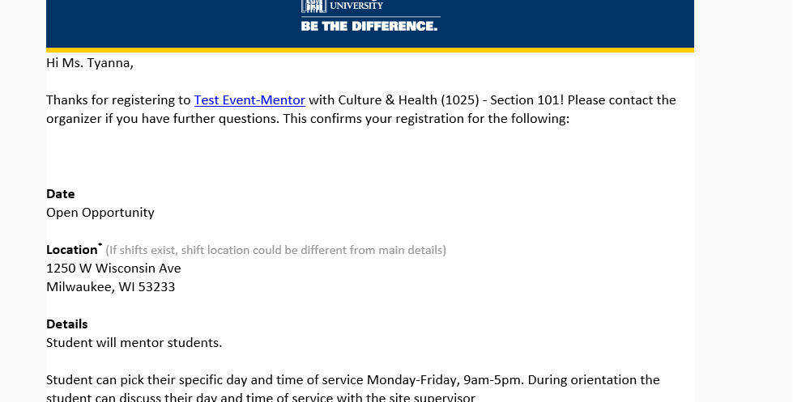

How to Register for a Reflection Session

Log into MUEngage
Go to your academic course group
In the EVENTS section type in reflection session. You should see the screen below reflective of your course (this is only an example):

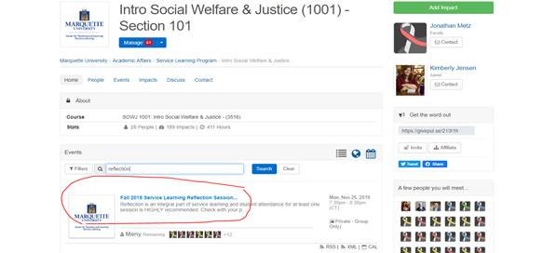

Click on the event title: [Name of Semester] Service Learning Reflection Session and follow the instructions.

How to Record Your Impact (i.e. Service Learning Hours)

Students can now log/record service learning hours through MUEngage. Impacts and Service Learning Hours mean the same thing. After you finish your work at the organization for the day, you will receive a reminder (a couple of reminders) to record your impact (service learning hours) on MUEngage. It is the student’s responsibility to record all impacts throughout the semester before the last week of classes. All impacts/hours are verified by the Service Learning Program and your supervisor at your service learning placement. Professors can also see if you completed your hours. If you do not record your impacts/service learning hours in MUEngage, there is no way to verify you registered and completed service learning hours.

Log in to your MUEngage account and SCROLL OVER HI (YOUR NAME) and CHOOSE ADD IMPACT.
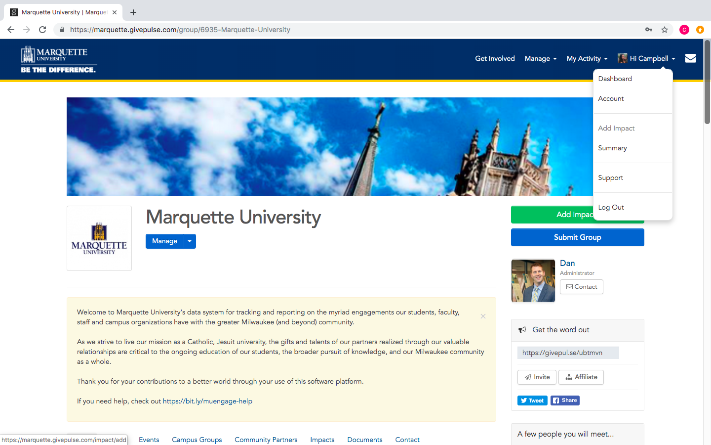

You are then asked where you created the impact (i.e. completed your service learning hours). You can search for the group (service learning program community partner) where you completed service.
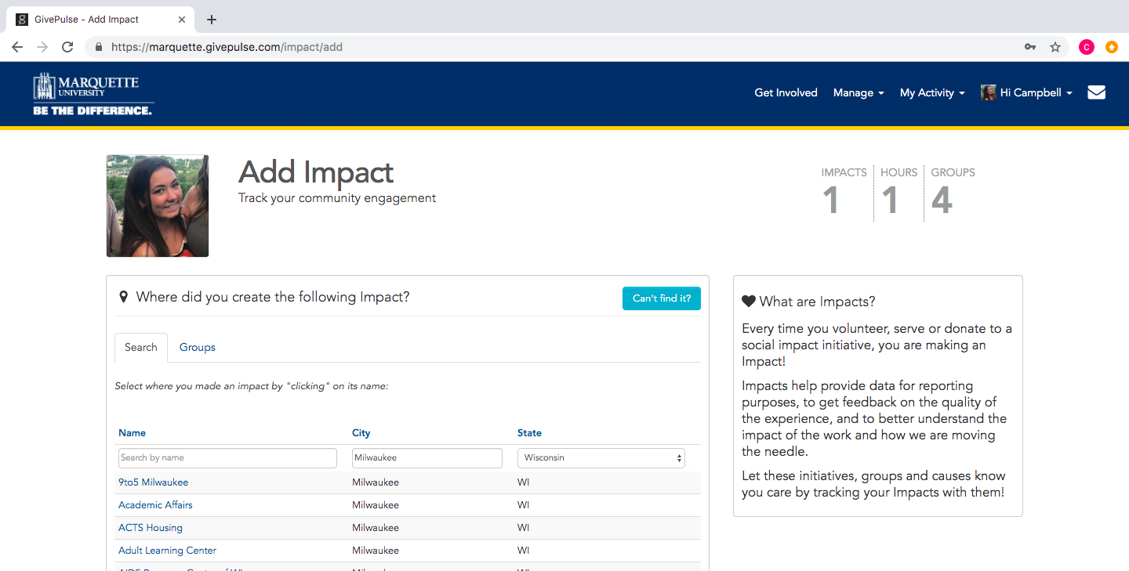

Or you can select from the list of groups/classes you are a member of.
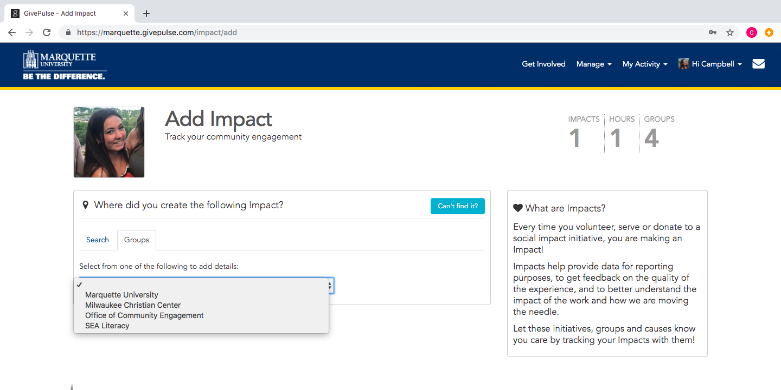

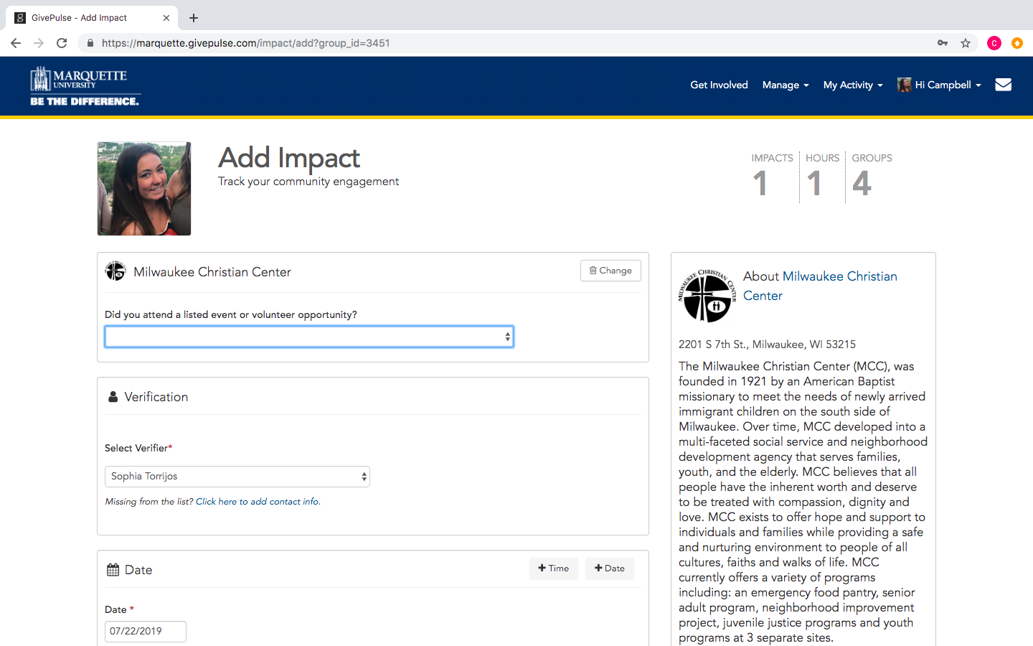
Fill out information about your service experience

In the Select Verifier section, choose your Student Coordinator as the verifier. The Service Learning Program can only verify hours for event templates created by a staff person from the Service Learning Program. If you don’t know who your Student Coordinator is, contact the Service Learning Program office.

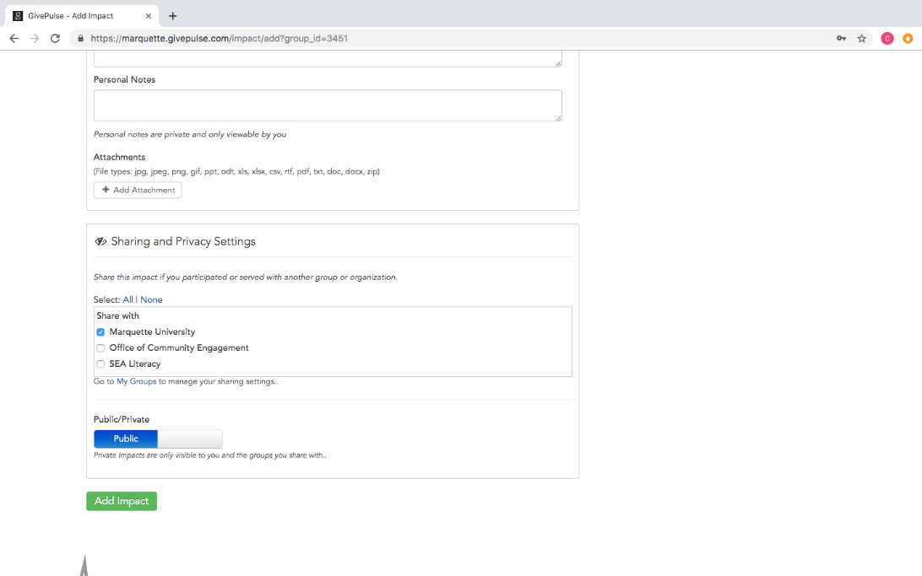
If you are taking more than one service learning course, in the SHARING AND PRIVACY SETTINGS section, make sure you share the impact with your other service learning course.

Once you are finished filling out the correct information, click Add Impact. The Student Coordinator and/or Site Supervisor of your event will verify the Impact.

The following instructions are for:

- students who forget to record their impacts
- students who are completing service learning at an organization not partnered with the Service Learning Program
- students who are doing special projects with organizations

If none of the above situations apply to you and you still have questions on how to record your impacts, please contact the Service Learning Program.

Forgot to Record Impacts:

- Go to MY DASHBOARD

- View MY REGISTRATIONS → PAST EVENTS

- Click ADD IMPACT on specific event and fill out event details

- Click SAVE IMPACT

Record Impacts for Independent Placements? (Organizations that are not Service Learning Community Partner and/or not listed in MUEngage):

- Go to MY DASHBOARD
- Click the DOWN ARROW next to your name
- Click ADD IMPACT
- Click on the blue, CAN’T FIND IT?
- Type in the Group (i.e. Organization’s Name) Name
- Under Verification, type in the Name, Email, and Phone Number of your site supervisor (a person who can verify you completed your service learning hours). All information is verified by the Service Learning Staff.
- Under DATE, enter the date for service. Click TIME and enter the time of service. You will need to do this EVERY TIME you are completing service at the organization.
- Under IMPACT TYPE AND MEASUREMENT, select TIME, then add the number of hours you completed on that specific day of service.
- Under Requested Information, you can choose to answer the questions
- Under ABOUT YOUR EXPERIENCE, you can choose to rate the experience and add any personal notes
- Under SHARING AND PRIVACY SETTINGS, make sure you select the groups (i.e. your service learning courses) to share your service hours. If you do not share the hours with your service learning course, your professor will not see your service learning hours.
- Click ADD IMPACT
Remember you must complete an Hours Timesheet in addition to entering your impacts in the MUEngage. If you do not submit an Hours Timesheet at the end of the semester your hours in MUEngage will not be verified.

Record Impacts for a Service Learning Project or Presentation (One-time, limited engagement with an organization):

- Go to MY DASHBOARD
- Click the DOWN ARROW next to your name
- Click ADD IMPACT
- Use the DROPDOWN MENU to select the class to record impact
- Under Verification, you should see your professor’s name as the Verifier. If not, select CLICK HERE TO ADD CONTACT INFO and type in the Name and Email of your professor (no need to add the professor’s phone number).
- Under DATE, enter the date for service. Click TIME and enter the time of service. You will need to do this EVERY TIME you are completing service at the organization.
- Under IMPACT TYPE AND MEASUREMENT, select OTHER, then provide a brief explanation of the project you completed.
- Under Requested Information, you can choose to answer the questions
- Under ABOUT YOUR EXPERIENCE, you can choose to rate the experience and add any personal notes
- Under SHARING AND PRIVACY SETTINGS, make sure you select the groups (i.e. your service learning courses) to share your service hours. If you do not share the hours with your service learning course, your professor will not see your service learning hours.
- Click ADD IMPACT

Delete or Update Impacts
If you mistakenly entered the wrong amount of impact hours or need to update your impacts, follow the directions below:
- Go to marquette.givepulse.com/user/impacts
- Find the impact in question and update it​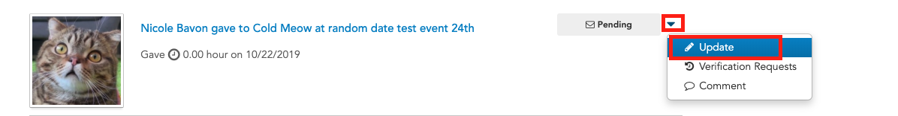​
- Scroll to the bottom of the update impact page and delete the impact​​

How to Create an Impact Summary

All recorded impacts stay on your MUEngage account until you graduate from Marquette. You can always go back into your account to create and print a summary of service completed as a MU student. If you leave MU or graduate, make sure you print a summary of your service activities to keep for your records. You do not need to print a summary for the Service Learning Program (we have all your information). Printing a summary is only for your personal records.

To Print A Summary of Your Service Activities as a MU student:

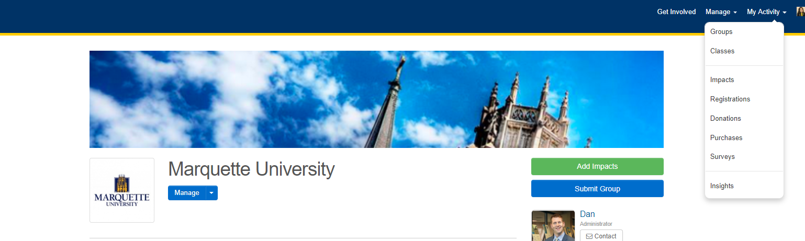
- Go to MY ACTIVITY dropdown on your home screen and click IMPACTS

- On the right of the screen, you can click PRINT SUMMARY

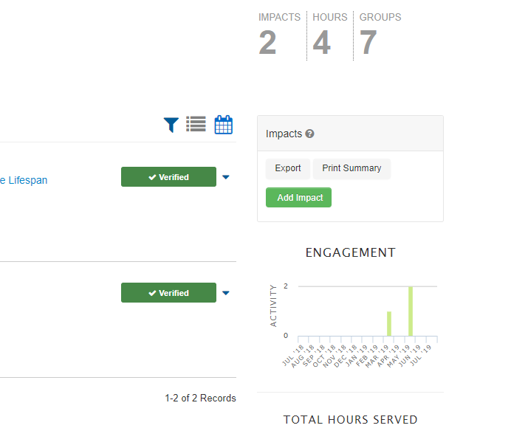

3. Below is an example of an IMPACT SUMMARY

